

**FPT APTECH COMPUTER EDUCATION**

**eProject - FANNoFAN**

**Student:** Ta Hoang Ha Student1312019

Nguyễn Văn Việt Student1311820

Phạm Văn Nam Student1308011

Nguyễn Ngọc Linh Student1311802

**Lecture:** Dang Kim Thi

**INTRODUCTION**

Nowadays, information technology has made strong progress along the way width and depth. Computers are no longer a precious medium rare but increasingly becoming a popular work and entertainment tool of people not only in the office but also in the family. Faced with the role of information on fierce competition, organizations and enterprises are looking for every measure to build and perfect the information system in order to computerize the unit's task activities.

Currently, the world's leading IT companies are constantly investing and improving solutions and products to enable commercialization on the internet. Through these products and technologies, we easily realize the importance and inevitability of e-commerce. With simple operations on the machine

With an internet connection you will have at your fingertips what you need without having to spend much time. You just need to go to the e-commerce service pages, follow the instructions and click on what you need. Service providers will bring it to your home.

In Vietnam, there are also many businesses that are commercializing on the Internet, but due to difficulties in infrastructure such as telecommunications, which have not yet developed strongly, electronic payment services through banks are not popular, so only stop at the level of product introduction and order access through the web.

In order to approach and contribute to promoting the popularity of e-commerce in Vietnam, my group researched and completed the 'FANNoFAN fan product website'.

With her dedicated guidance: Dang Kim Thi, my group completed this graduation project report. Although we have tried our best to learn, analyze, design and install the system, it is inevitable that there will be shortcomings. I look forward to your understanding and suggestions. Thank you sincerely.

Through this, allow me to express my gratitude to the teaching and guidance of the teachers in the school. Especially Ms. Dang Kim Thi, who directly guided, guided and helped my team during the graduation project. I sincerely thank her for her kind guidance.

**PROBLEM STATEMENT**

FANoFAN Company is into manufacturing and selling on Fans. They manufacture fans for various needs of customers. From Ceiling Fans to Table Fans to Exhaust Fans, they are into all types of Fan Manufacturing. They are looking to come up with their own website and display all the products available with them. They want to provide a detailed information about all their products. The website is to be developed for the Windows Platform using HTML5, JavaScript and Geolocation. The site should work well in all leading browsers including Chrome, IE, Firefox etc.

**Requirement Specification:**

The Web site is to be created based on the following requirements.

1. The Home Page should be created making use of Sections with a suitable logo, the header section can be added which will show images Fans.
2. The site must contain the links to navigate through any category for the information.
3. Links of bottles can be categorized like (Ceiling Fans, Table Fans, Exhaust etc.)
4. Specification and Pricing of Fans can be added along with the images.
5. Gallery section can be added for viewing different images.
6. Feedback must be allowed to enter by the viewer
7. Site map, Gallery, about us, Queries link, Contact us link must be added. Address of the Company should be displayed using GeoLocation API (eg. GoogleMaps).
8. The complete description must be allowed to get download as pdf or doc file.
9. The advertise section with various facilities provided should be mentioned.

eProjects – HTML5 – FANNoFAN

**HARDWARE/ SOFTWARE REQUIREMENTS**

**Hardware**

* A minimum computer system that will help you access all the tools in the courses is a Pentium 166 or better
* 64 Megabytes of RAM or better

**Software**

* Notepad/HTML editor
* WebStorm 2021.1.1 x64
* IE , Chrome , FireFox ,…
* Balsamiq Wireframes
* Microsoft Word, Power Point

1. **Home Page**

* The Home Page should be created making use of Sections with a suitable logo, the header section can be added which will show images Fans.
* All items, pages are linked to a specific link or page

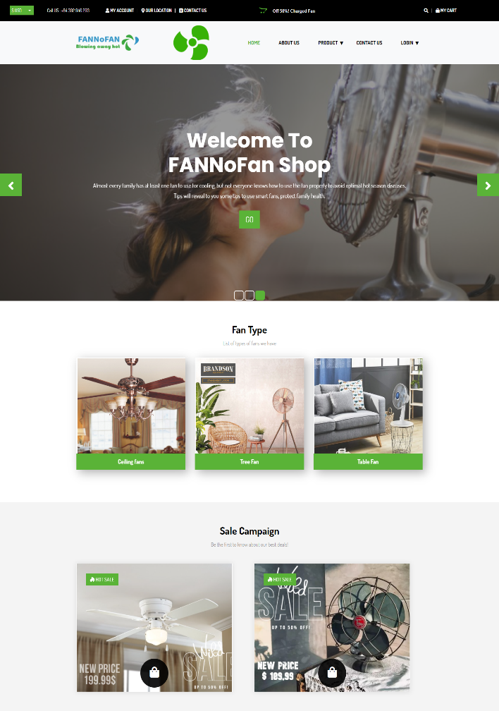 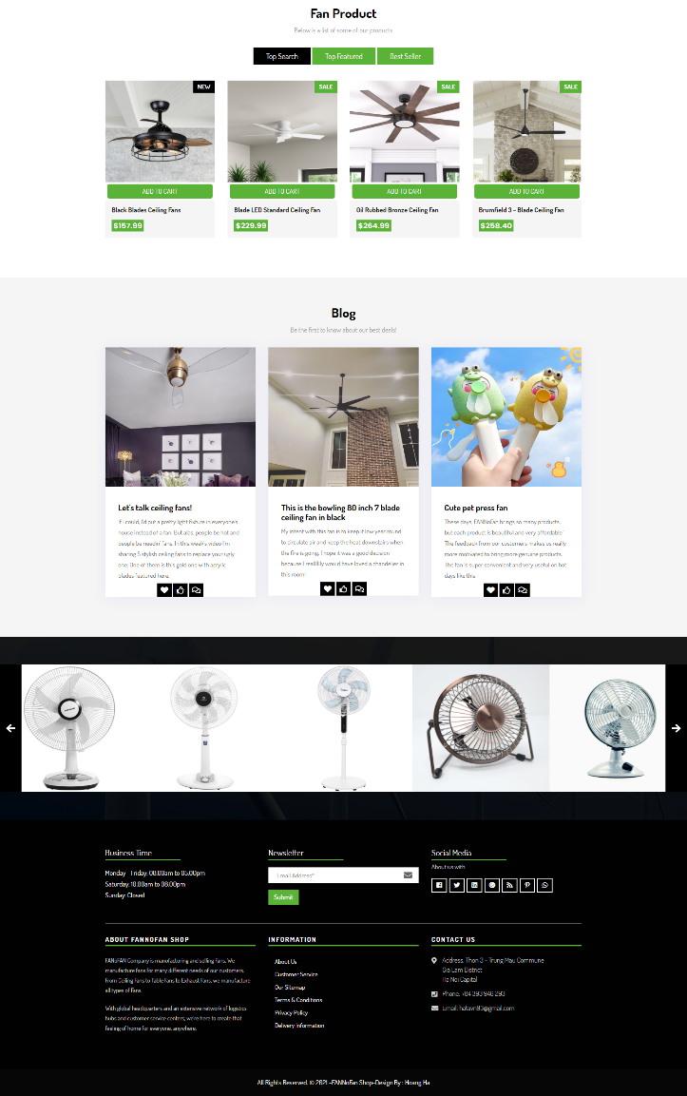

1. **About Us Page**

* This page introduces information about the company, about the creators of this website and the company's motto

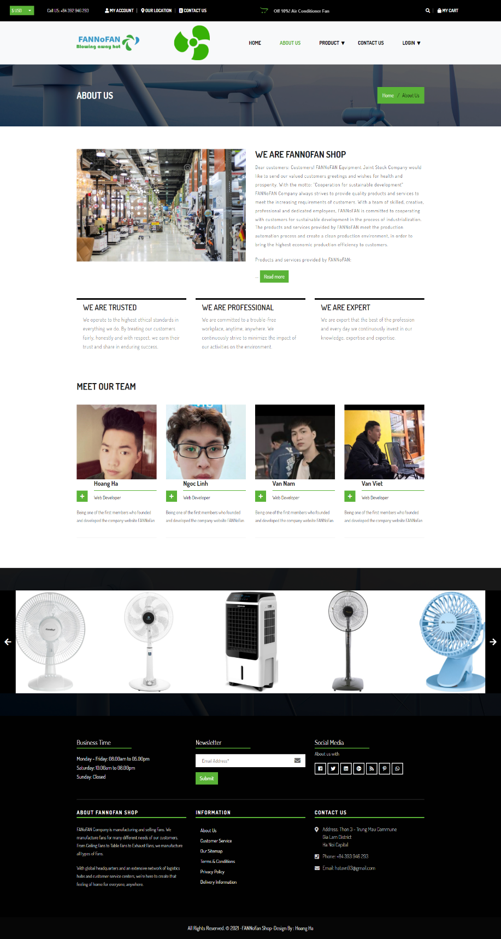

1. **Product Page**

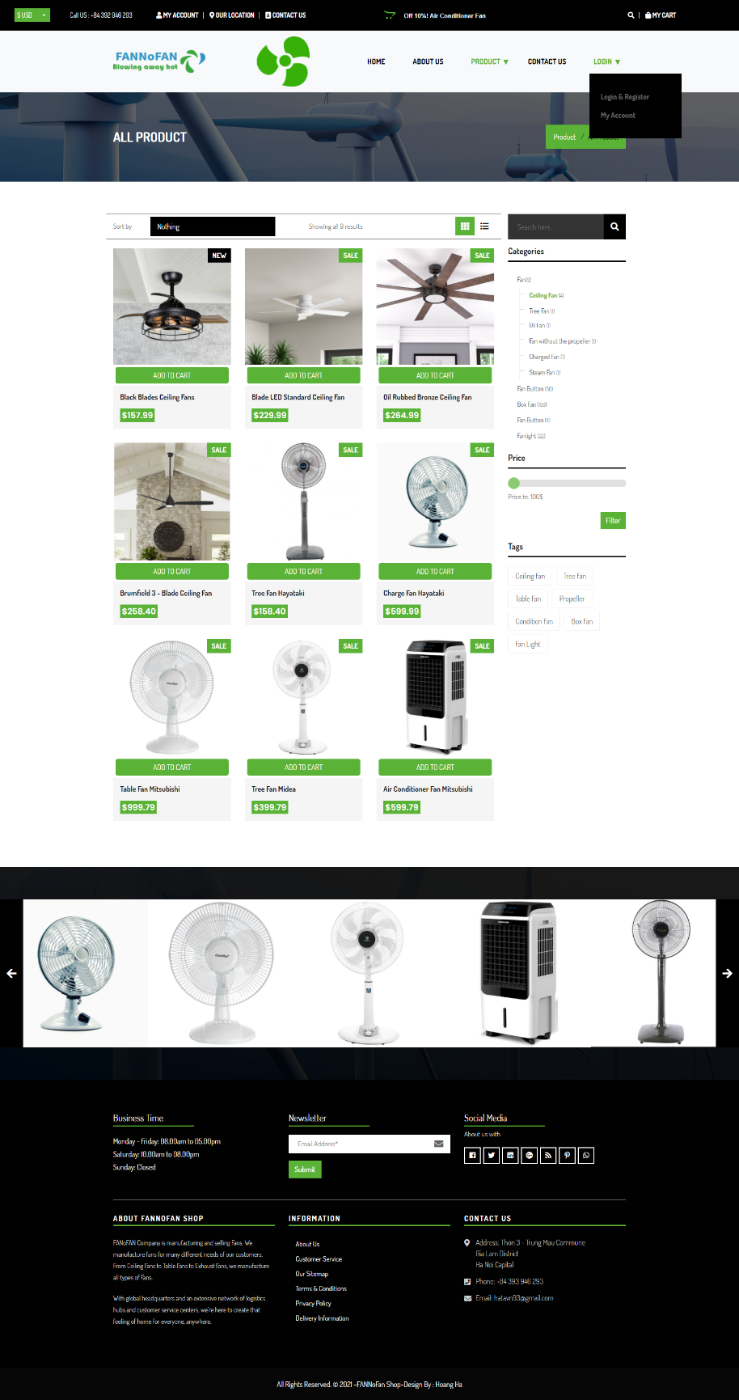

1. **Product Detail Page**

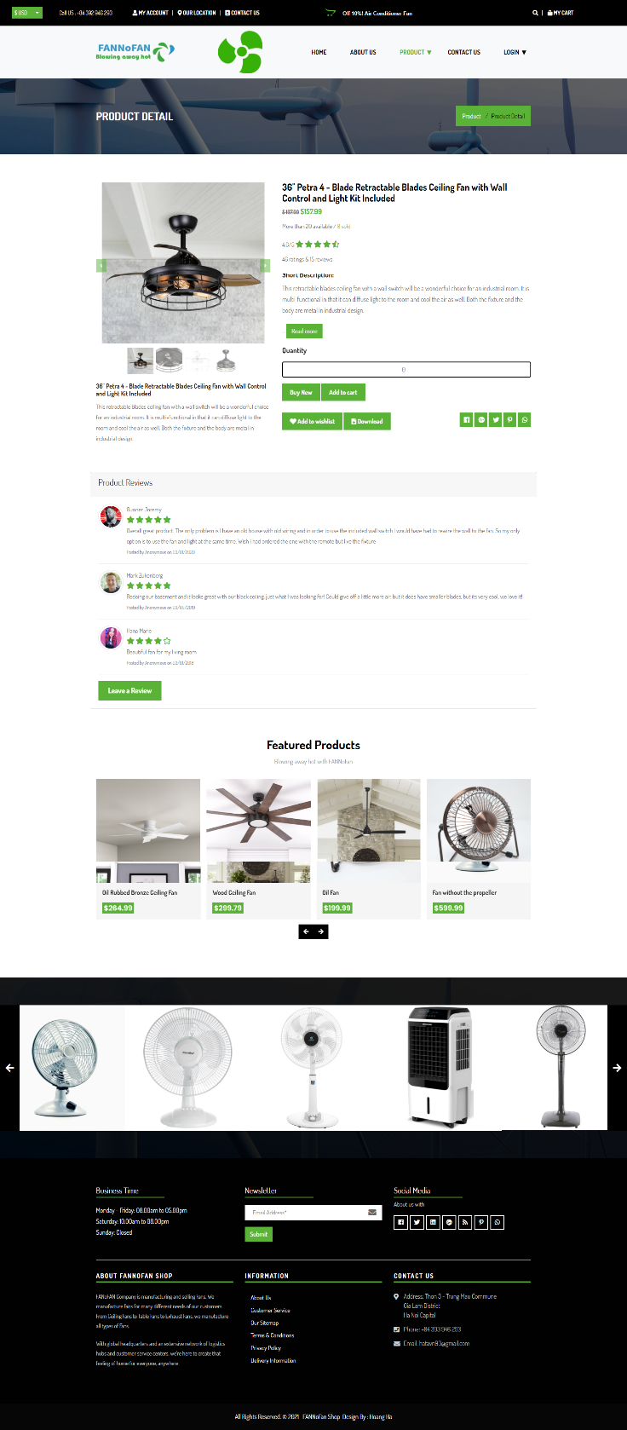

1. **Cart Page**

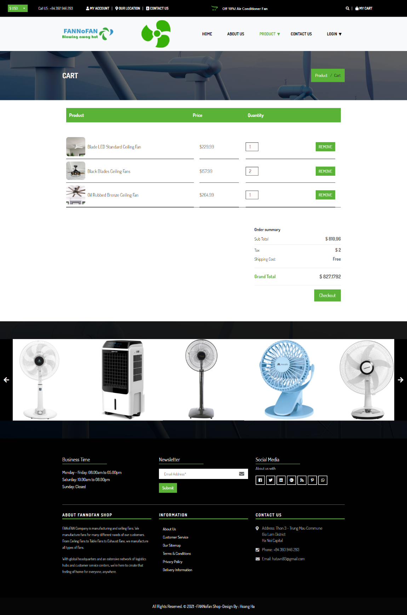

1. **Wishlist Page**

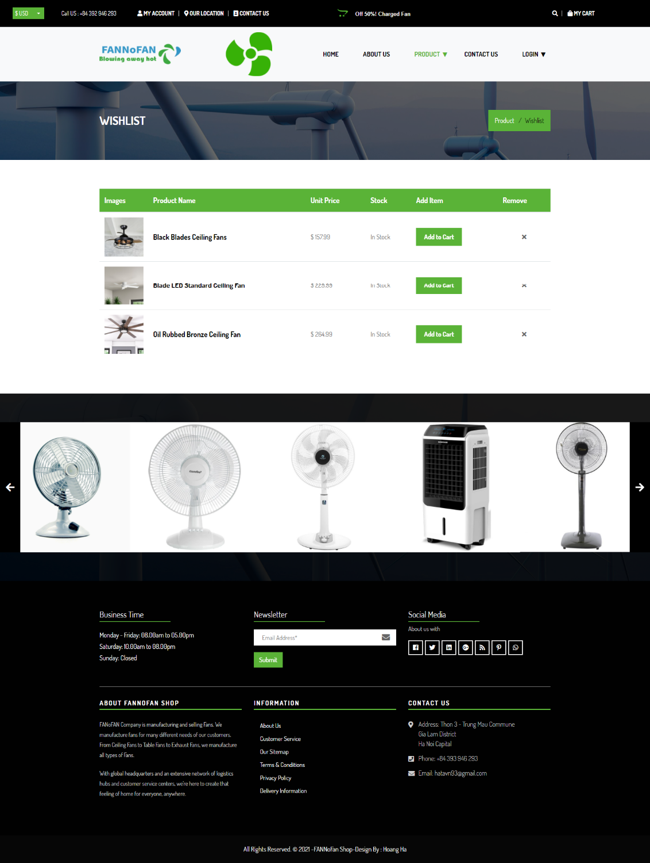

1. **Gallery Page**

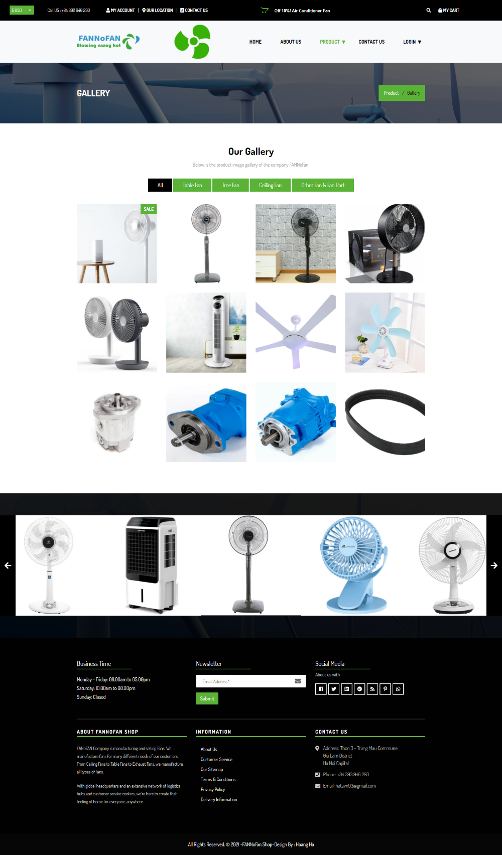

1. **Contact Us Page**

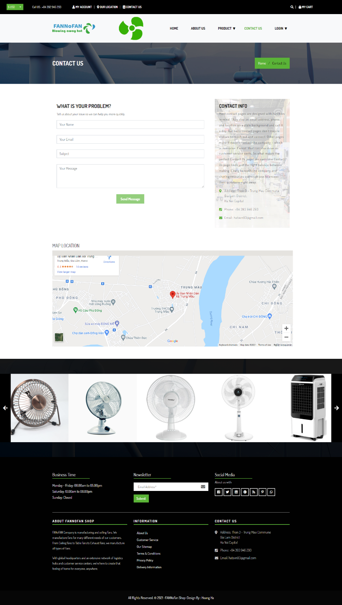

1. **Login & Register Page**

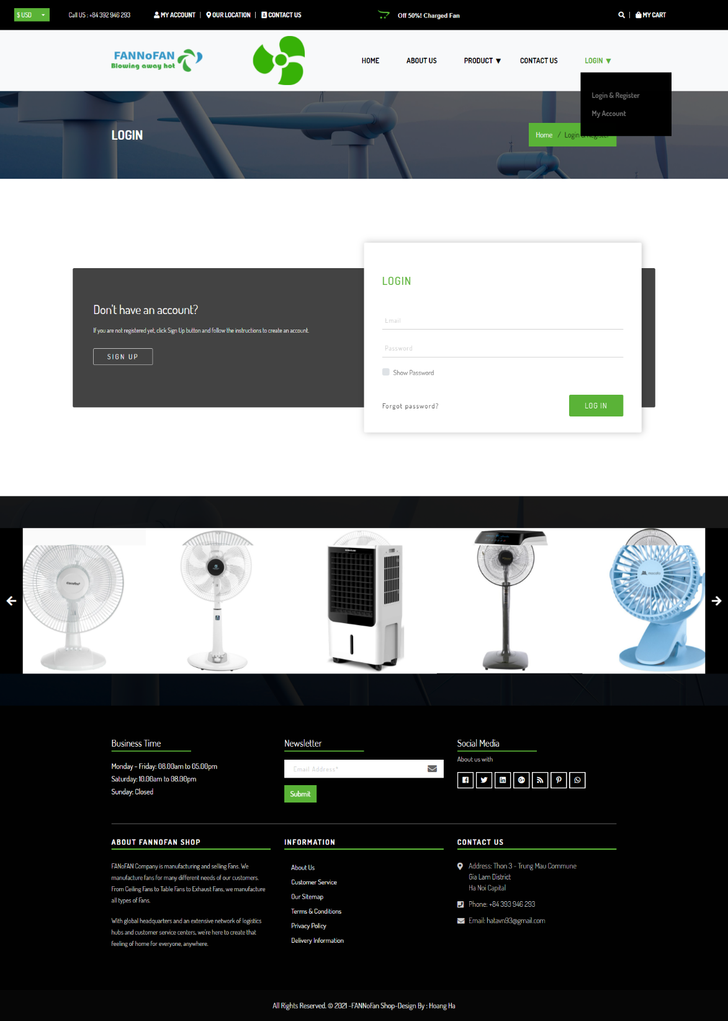

1. **My Account Page**

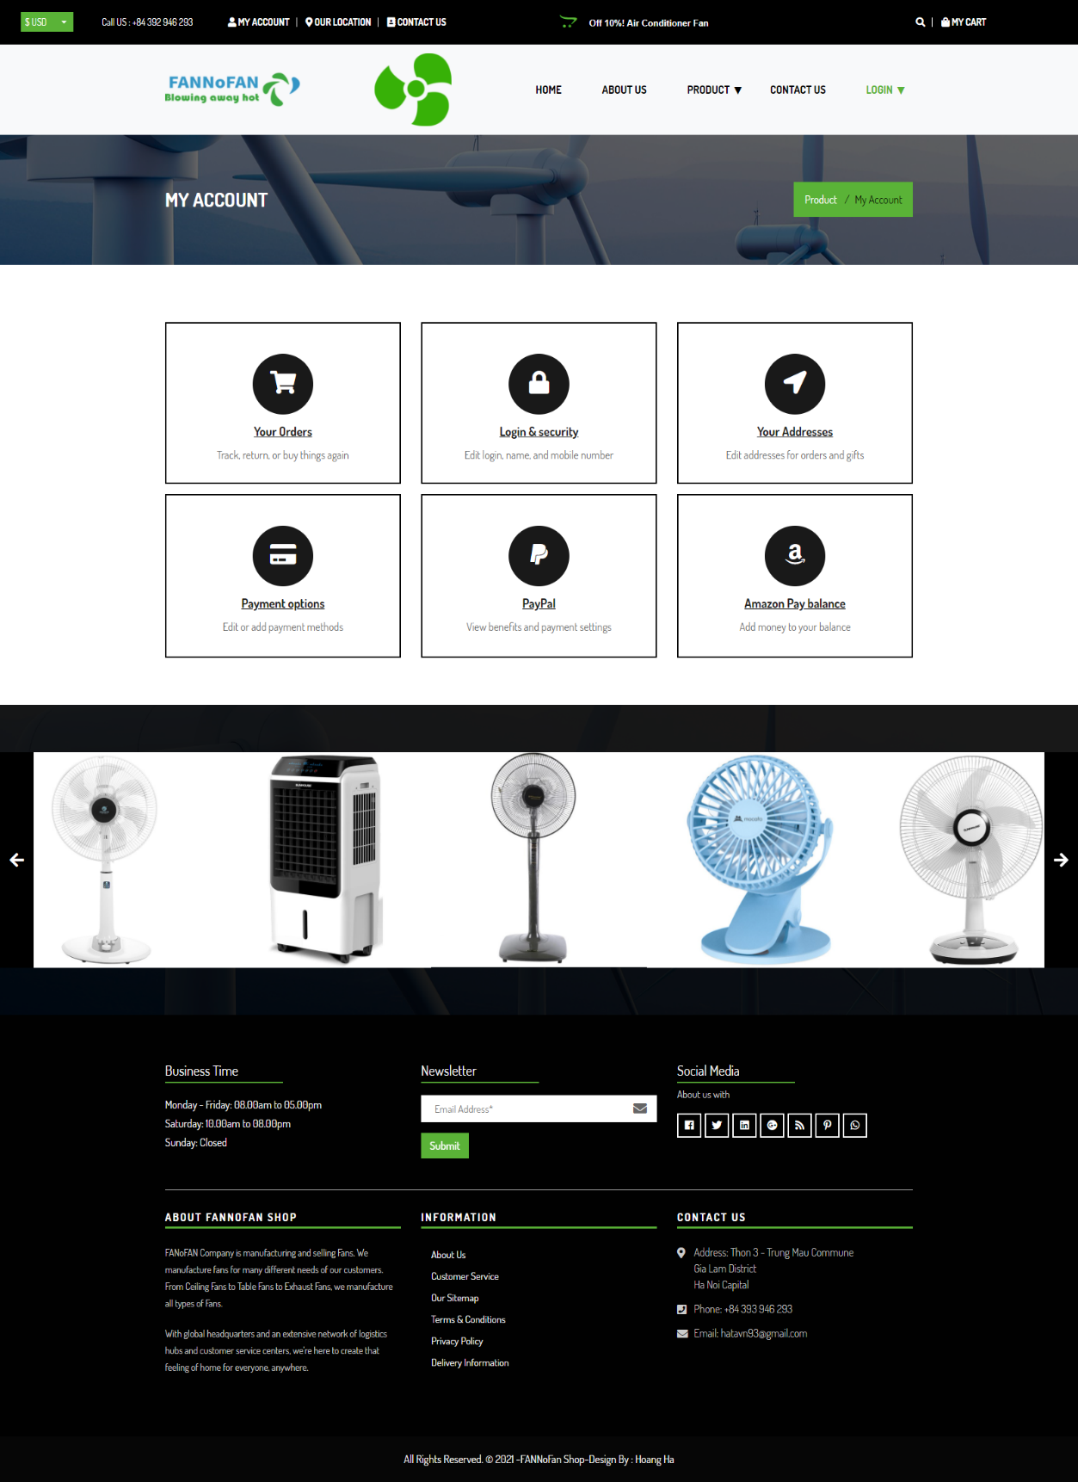

# Reported problems

* The homepage will use sections with appropriate icons, navigation bars and add fan icons for vivid, eye-catching and better user interaction.



* The company's products are classified as (Ceiling Fan, Table Fan, Tree Fan, etc.)

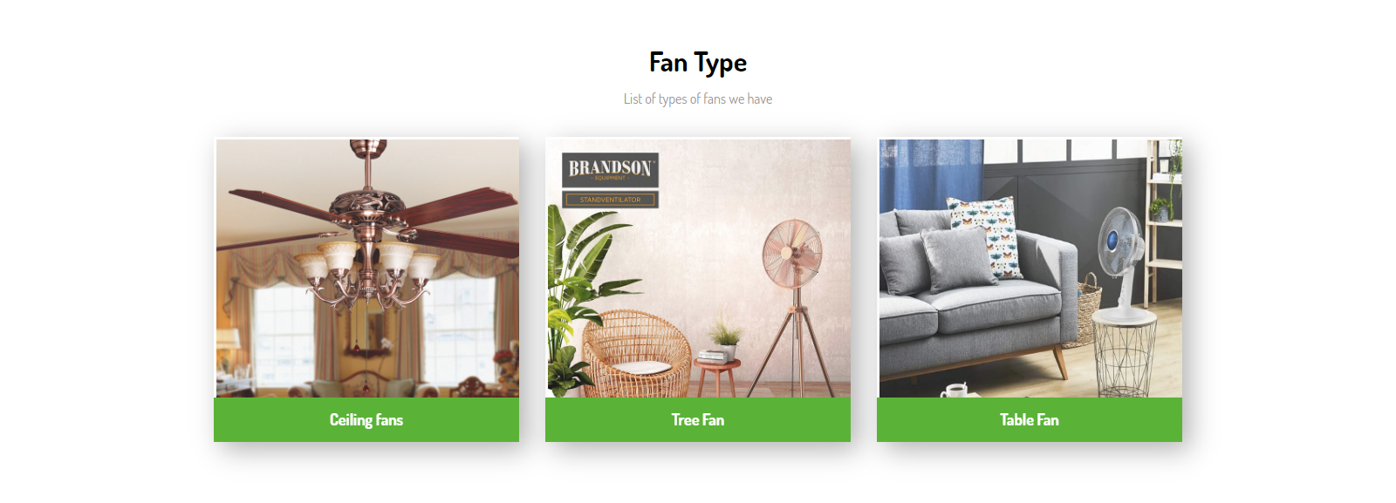

* Fan Specifications and Prices are added with images.

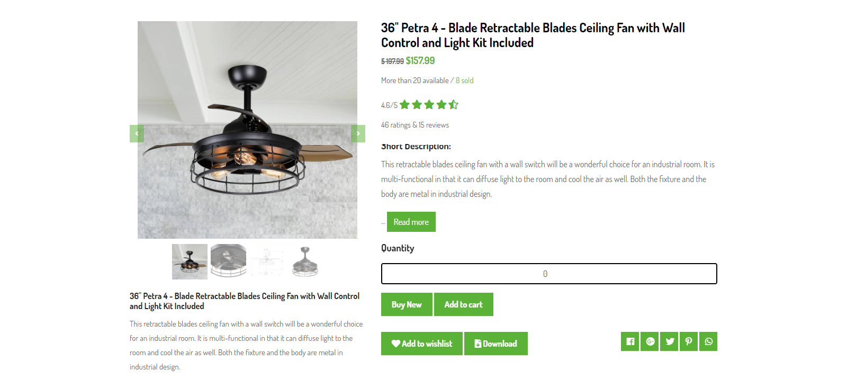

* Gallery section can be added to view different images of products and categorized for easier viewing by users

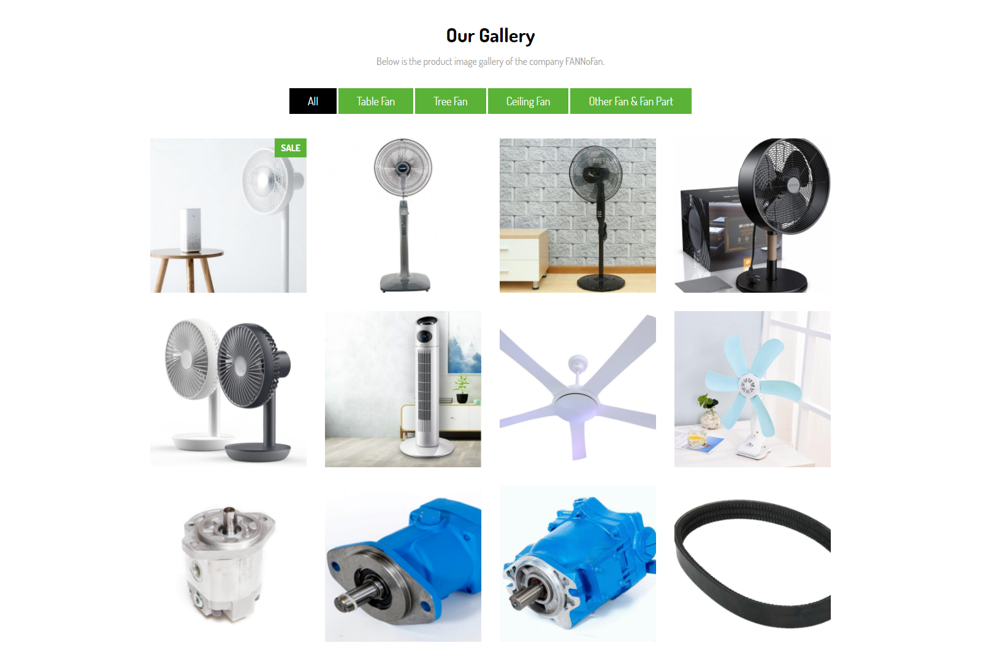

* Feedback must be allowed by the viewer

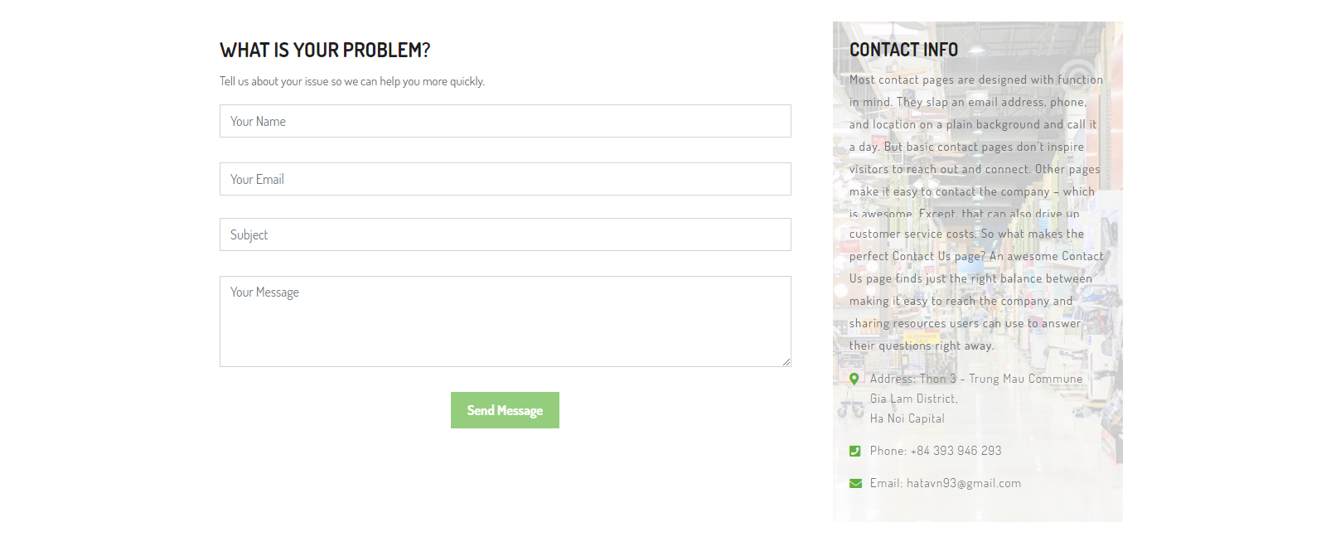

* Sitemap, Gallery, About Us, Query Link, Contact Us Link must be added. The Company's address must be displayed using the iFrame GoogleMaps).

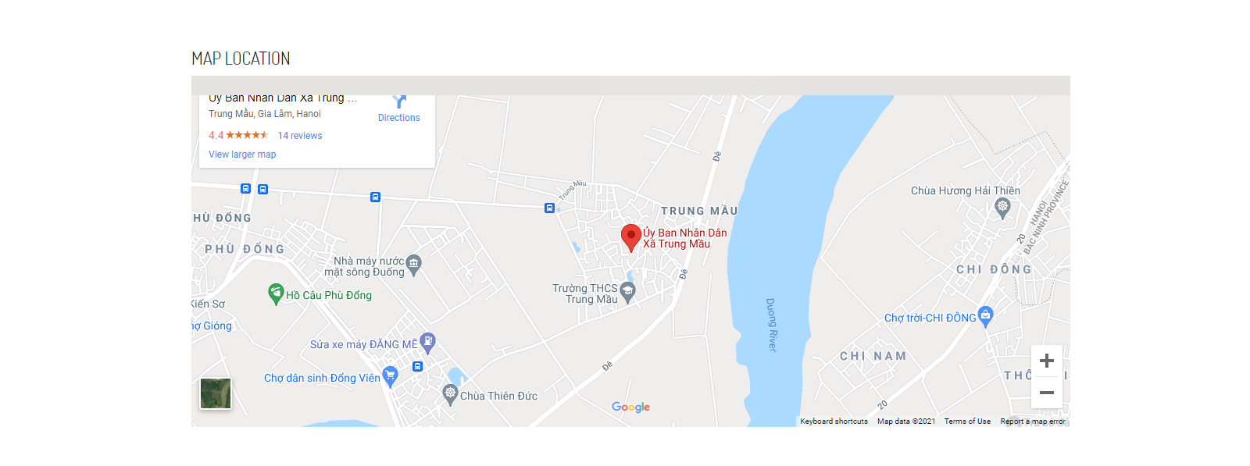

* The full description must be allowed to download as a pdf or doc file.

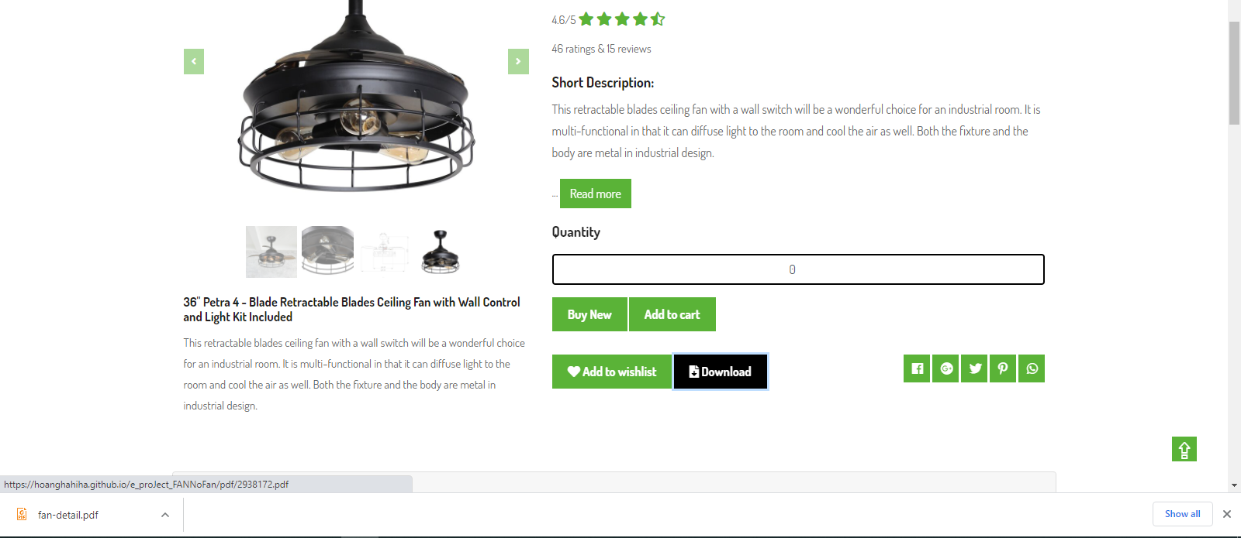

* Website works well on many different devices and platforms

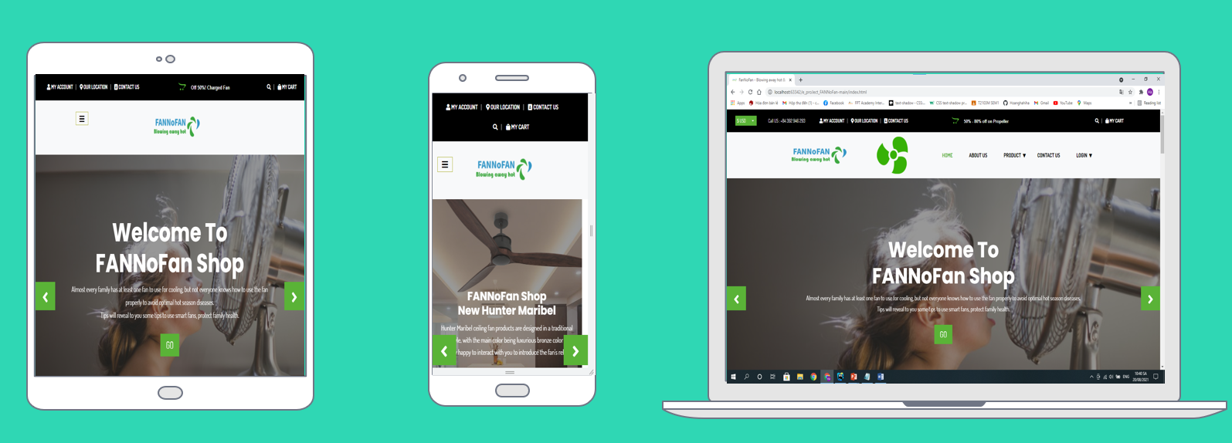

1. **Handle**

* **Offer box in header (using jquery)**



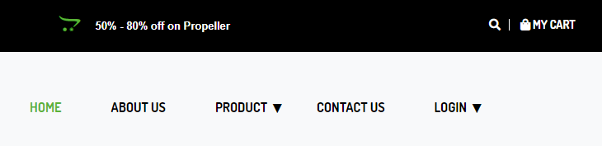

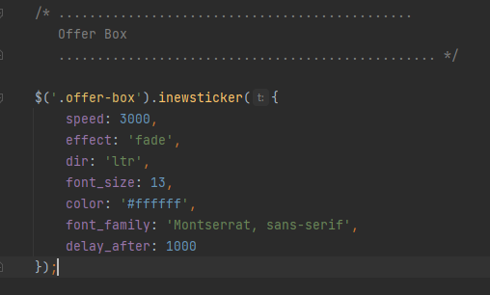

* **Main header & navbar (using Bootstrap, CSS & Jquery)**

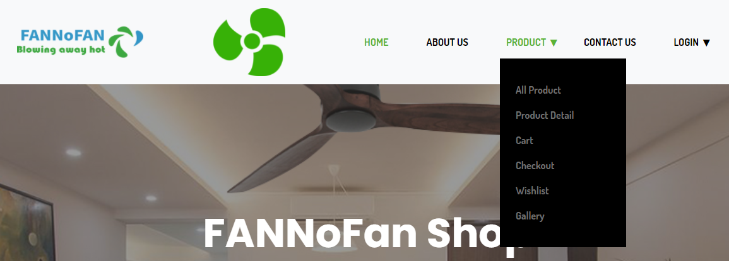

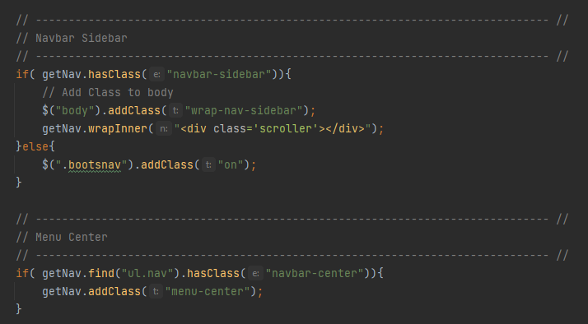

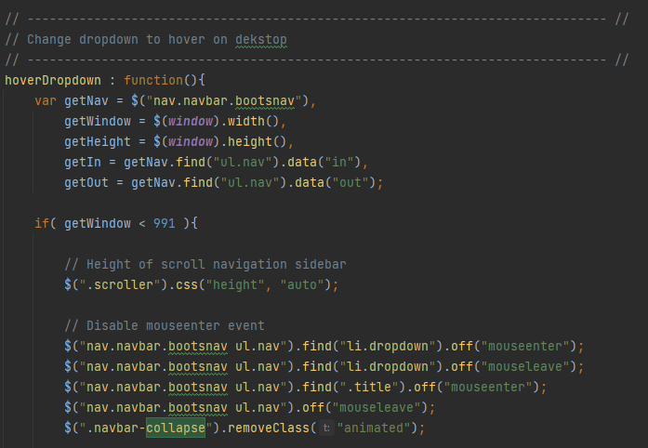

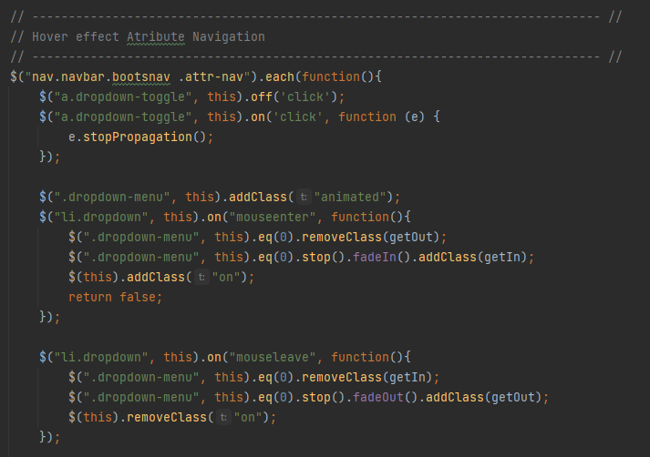

More details will be found in the files bootsnav.js and custom.js

* **Cover Slide (using Bootstrap, CSS & Jquery)**

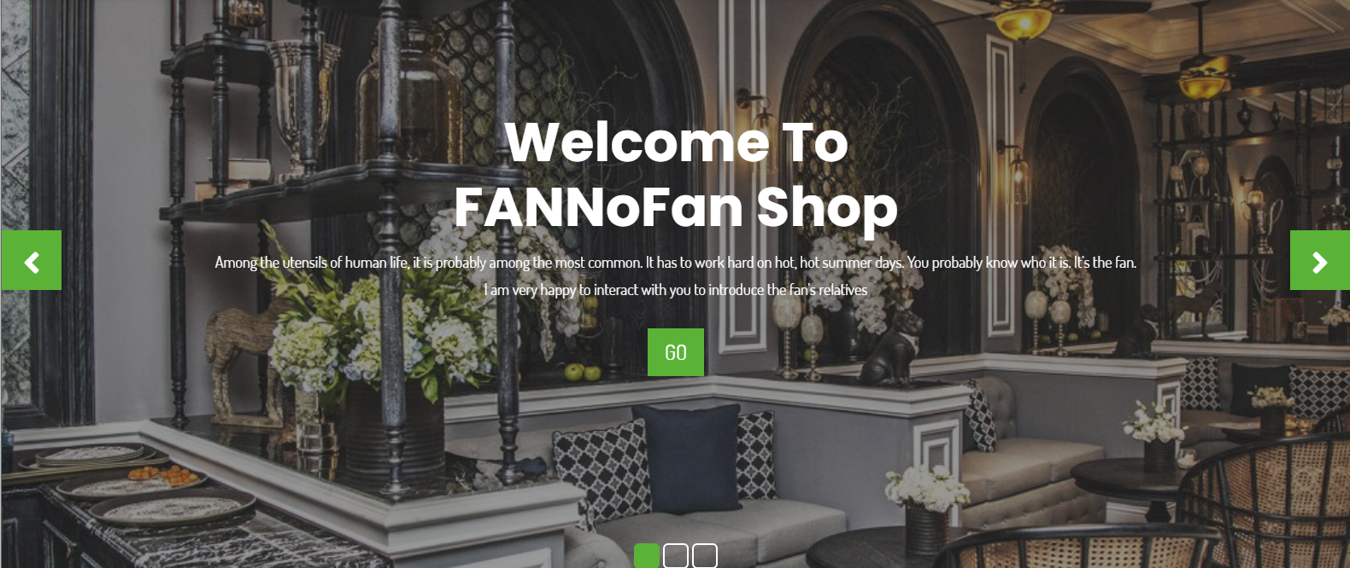

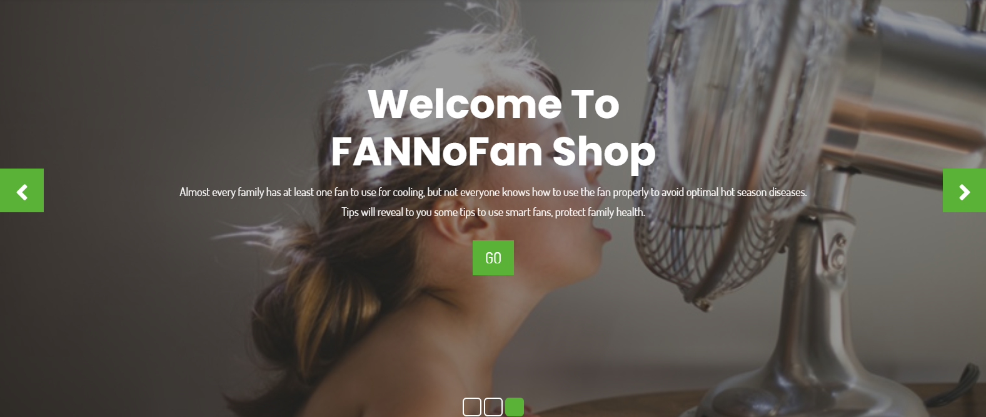

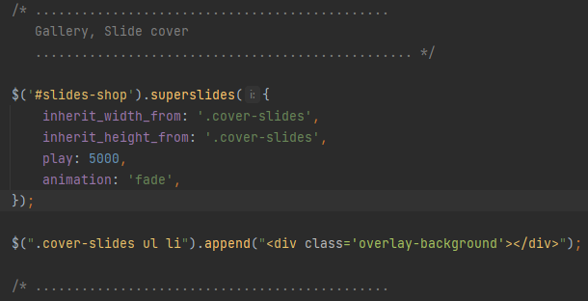

* **Fan type in Home Page (using CSS)**

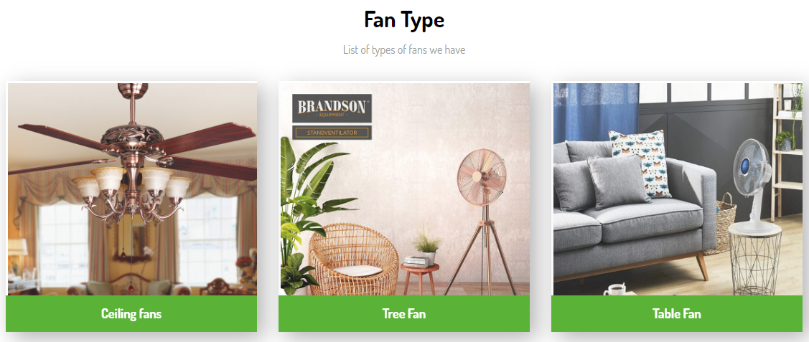

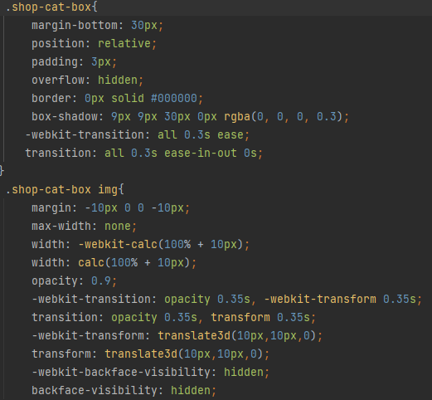 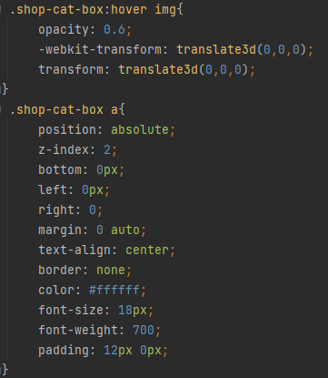

* **Data Fillter (using Bootstrap, CSS & Jquery)**

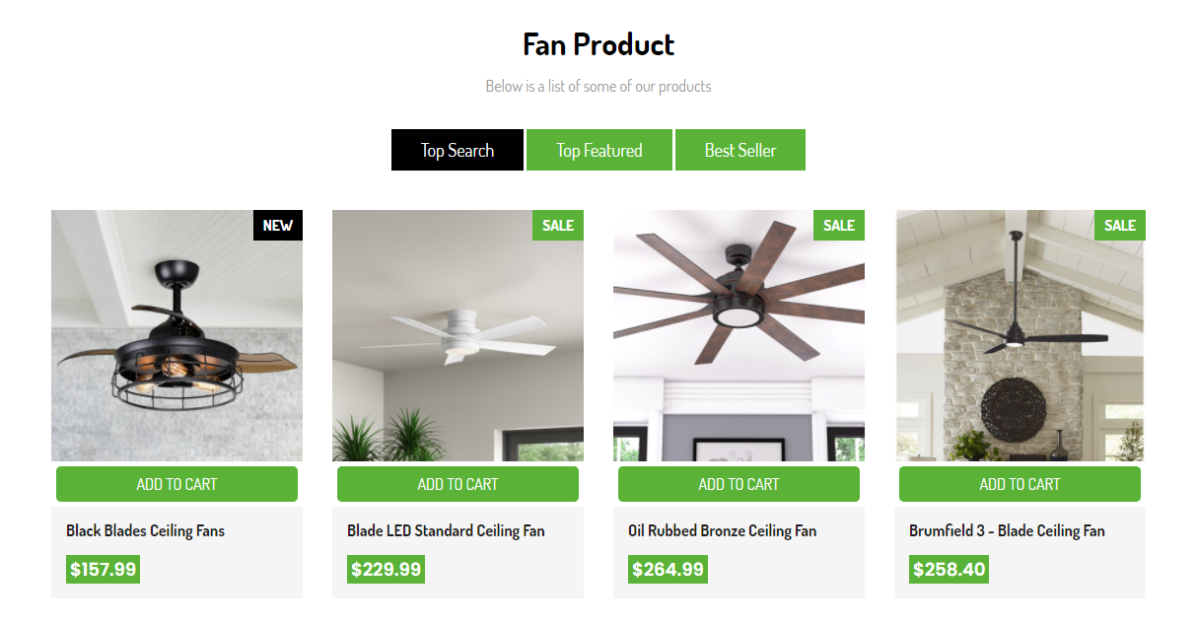

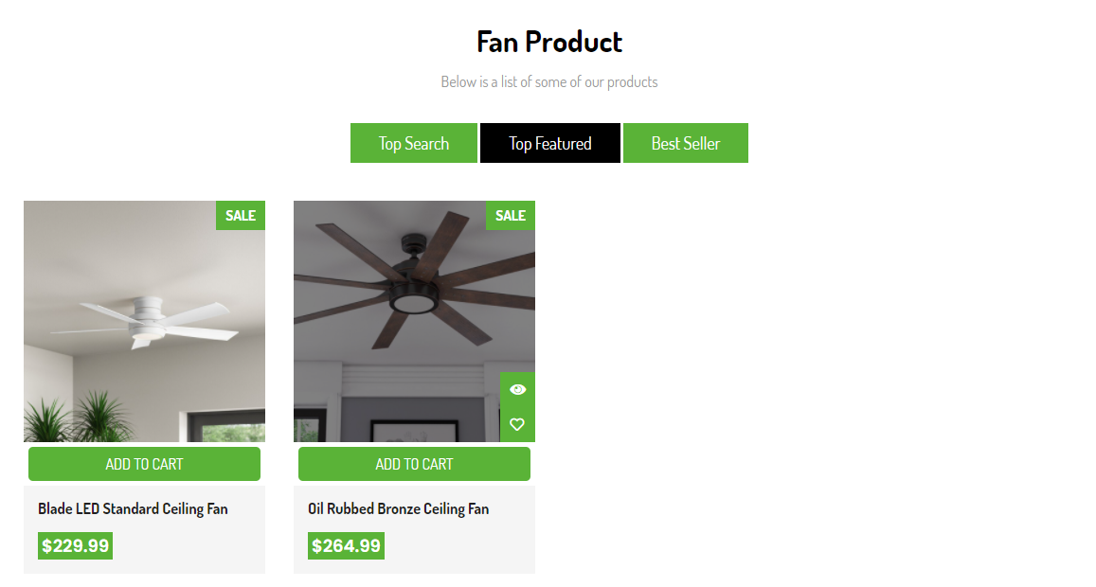

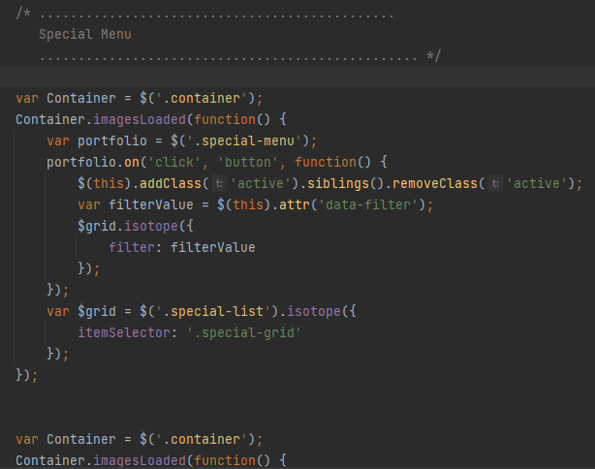

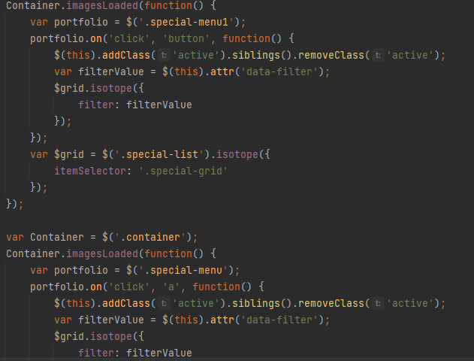

More details will be found in the files custom.js

* **Like and heart click (using CSS, javascript)**

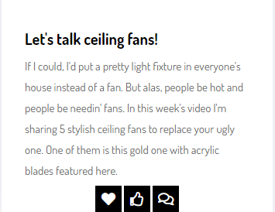 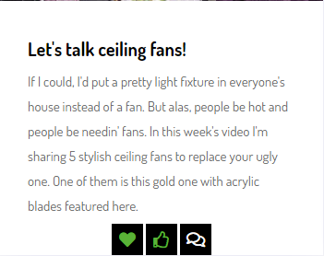

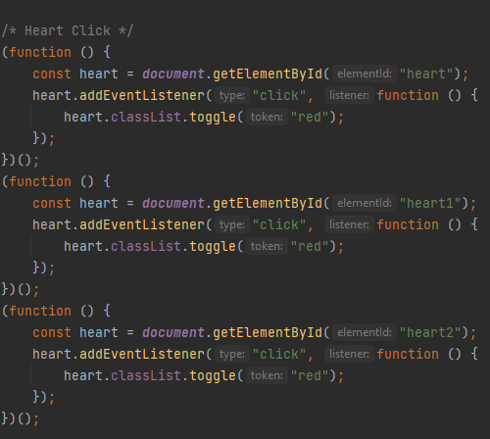 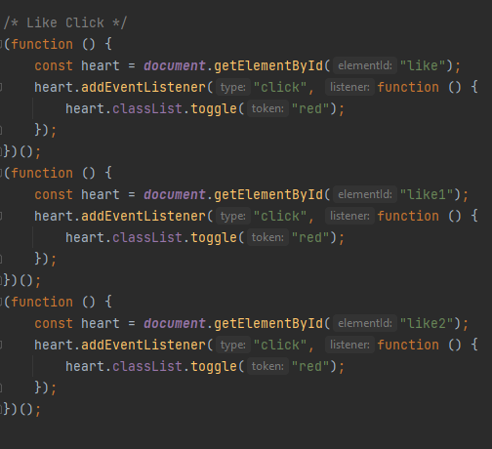

* **Owl Carousel Instagram Feed(using Bootstrap, CSS & Jquery)**

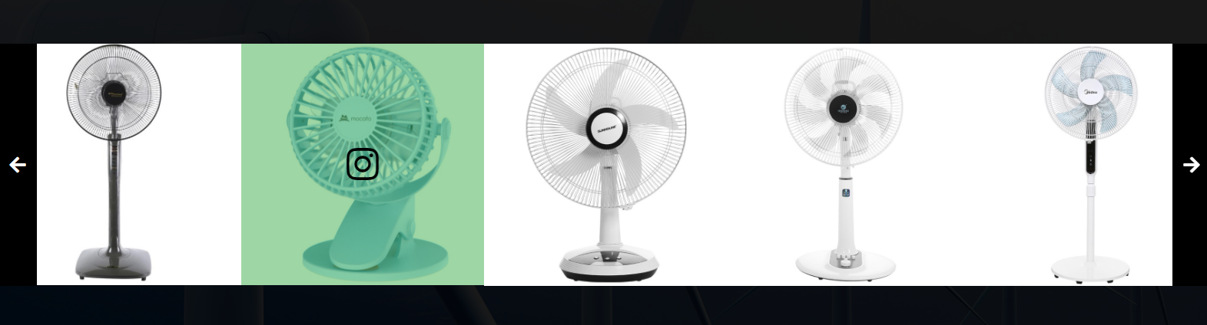

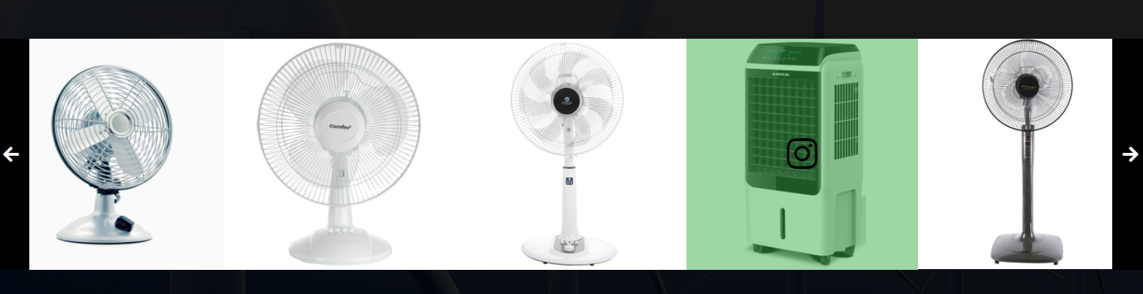

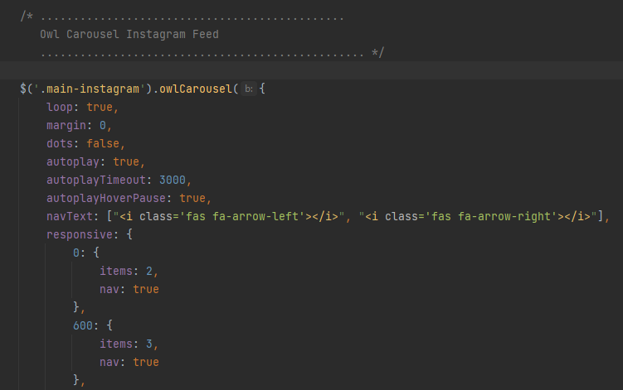

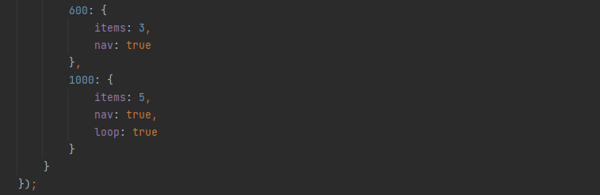

More details will be found in the files style.css(Instagram Feed)

* **Read more(using css & javascript)**

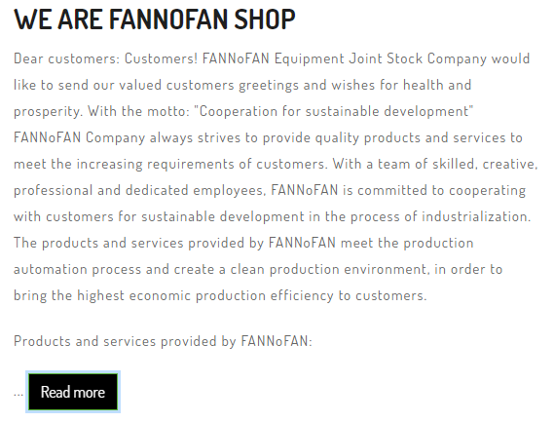

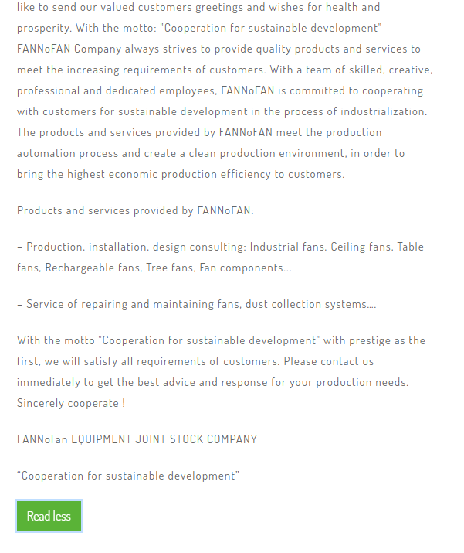

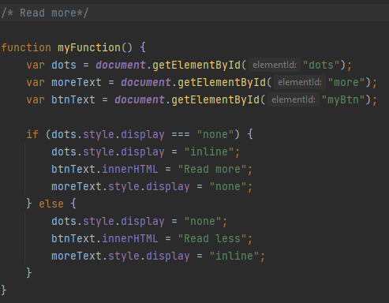

* **Hover block(using css)**





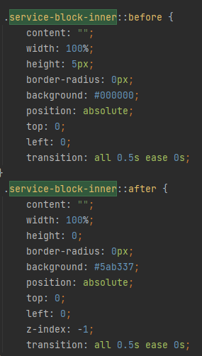 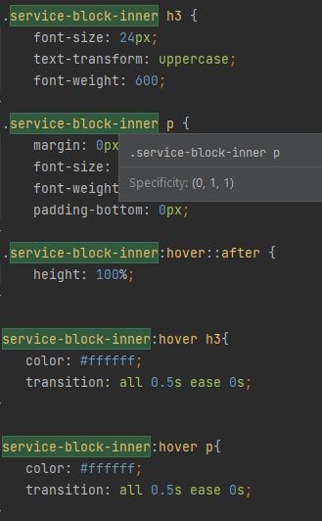

* **Product hover(using CSS)**

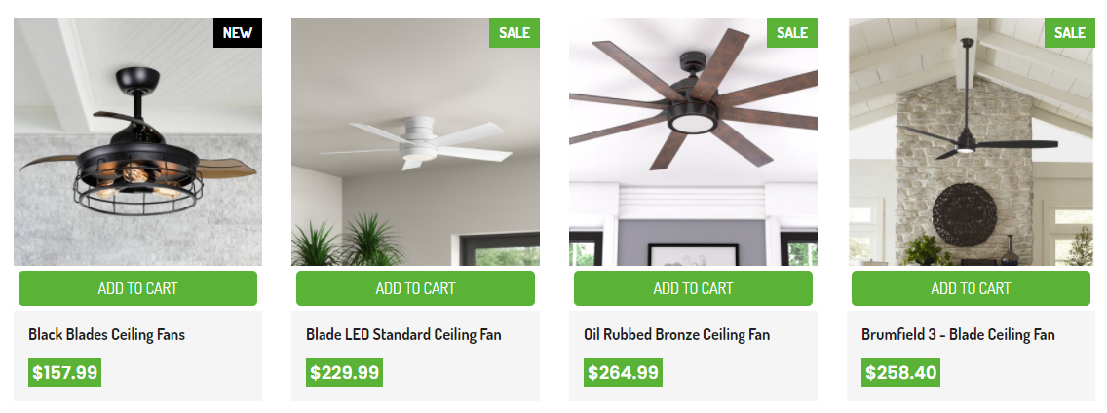

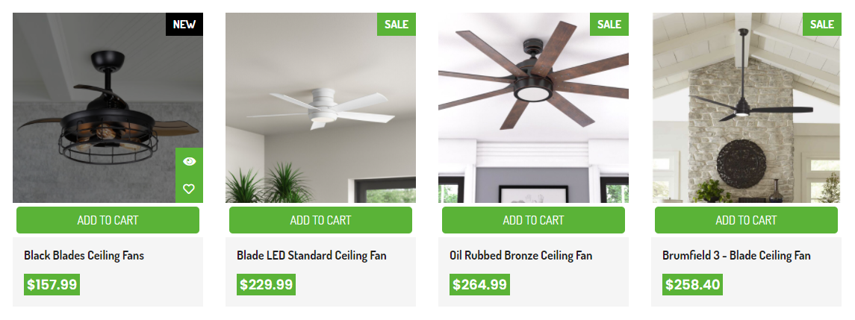

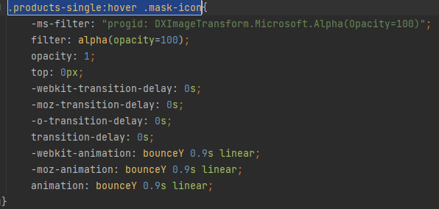

More details will be found in the files style.css(Products)

* **Ranger Slider(using CSS & javascript)**

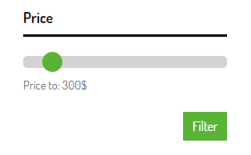

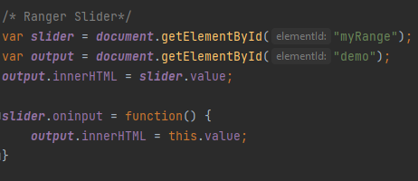

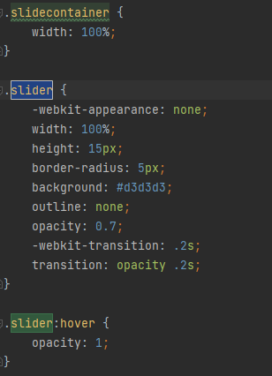 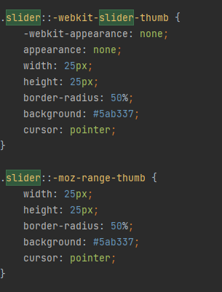

* **Image – Product – Slider(using Bootstrap & CSS)**

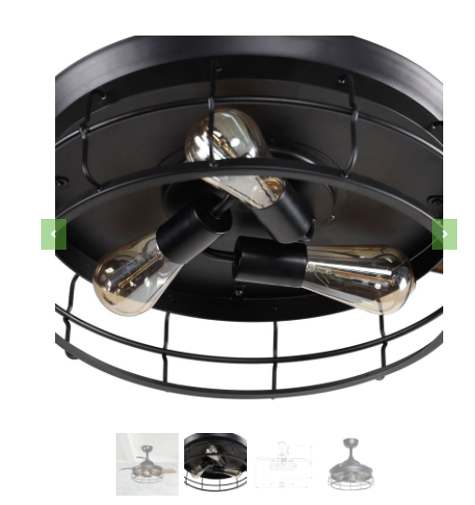 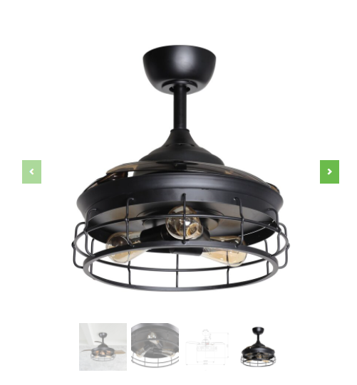

More details will be found in the files bootstrap.min.js

* **Download File (using HTML)**

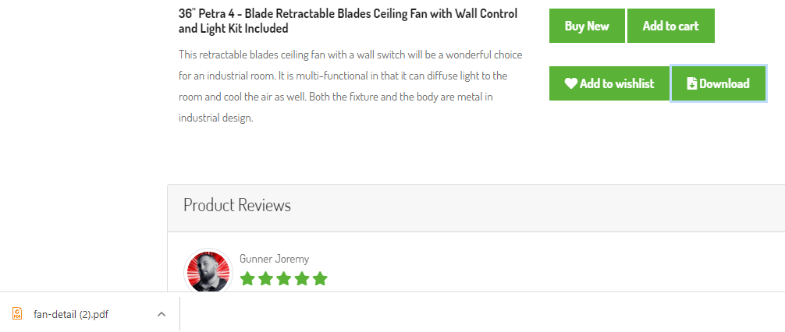



You can click “Download” button and file will downloaded

* Featured Products(using CSS, jQuery & Bootstrap)

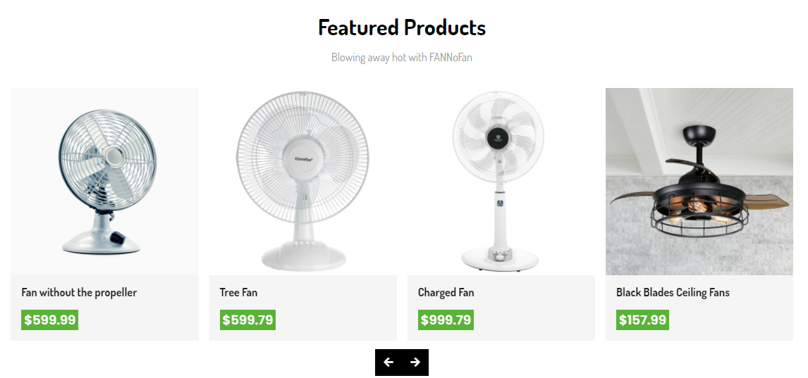

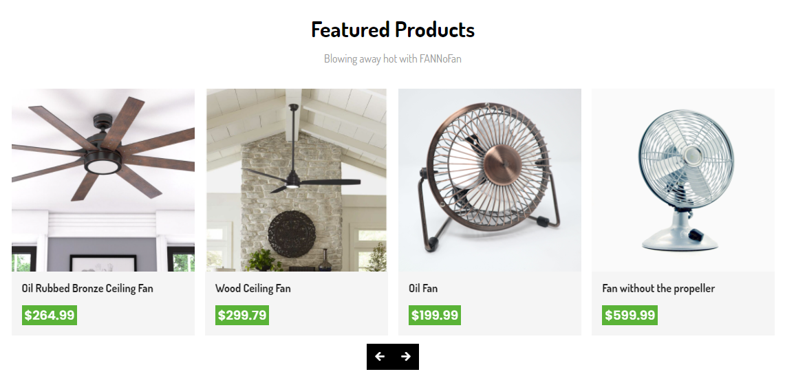

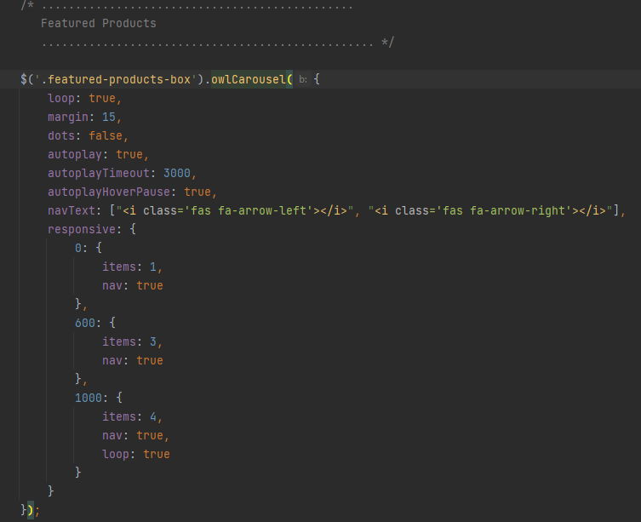

* Cart (using CSS, javascript)

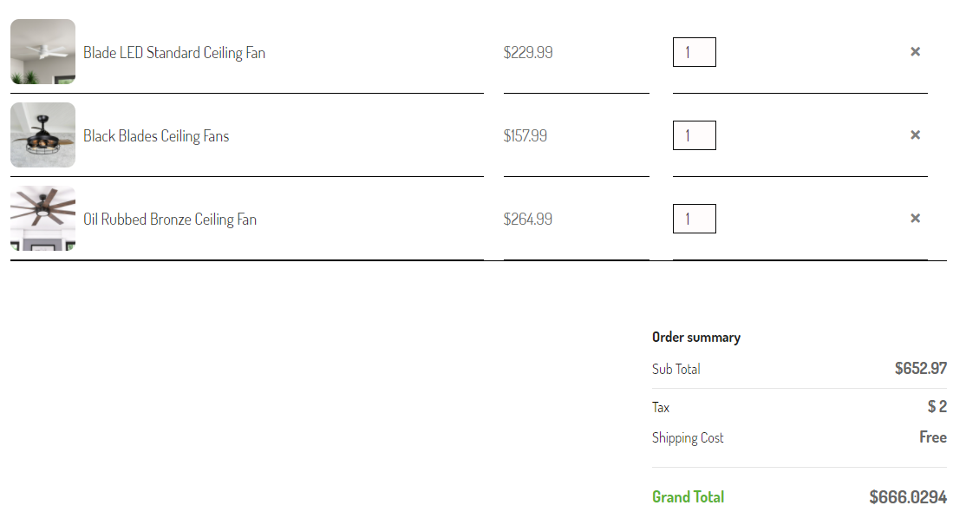

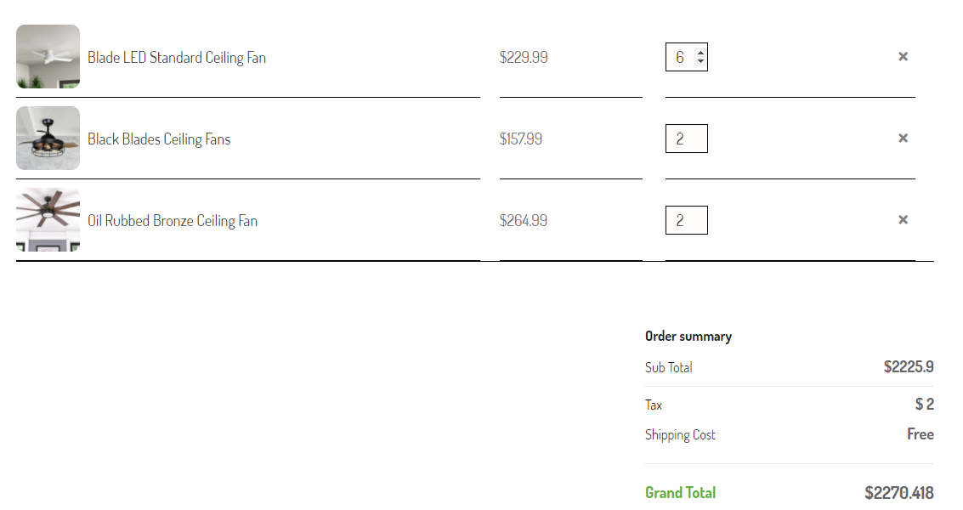

Before clicking “Add to cart”

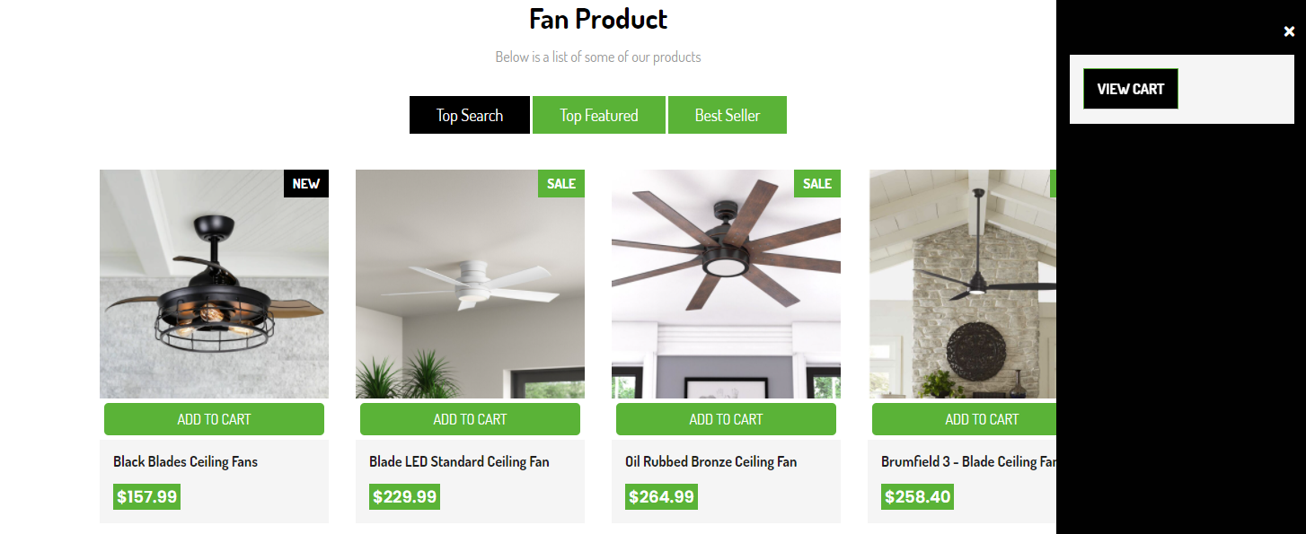

After clicking ”Add to cart”

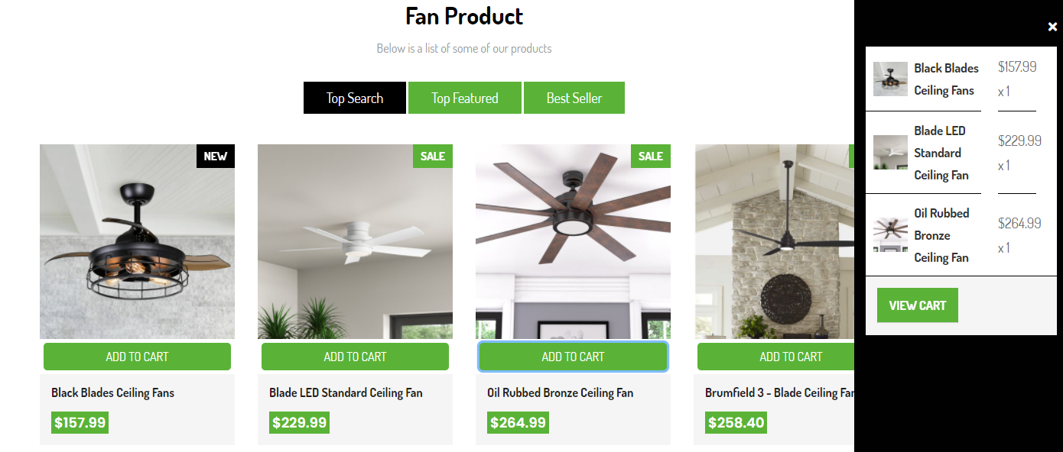

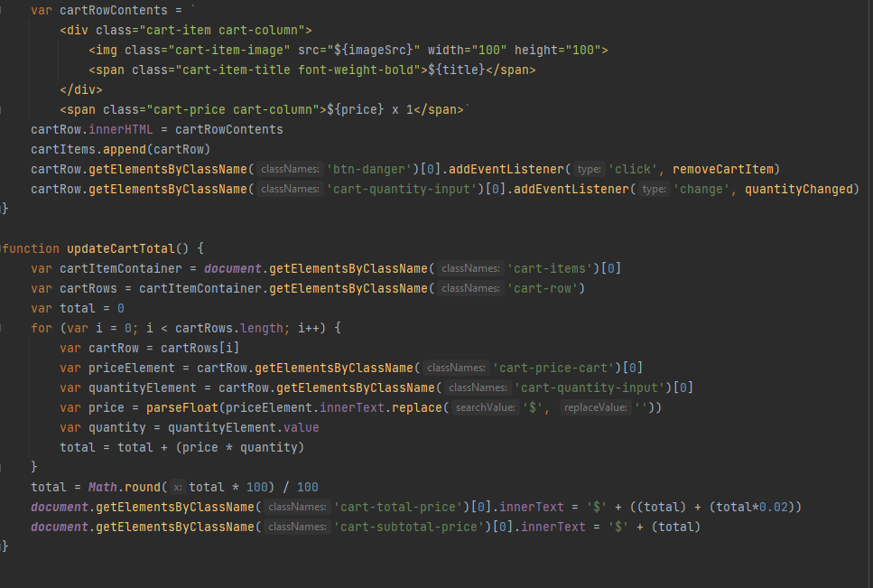

More details will be found in the files cart3.js

* **All forms are validated:**

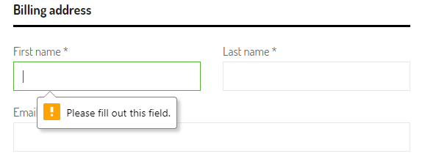

Once completed, you will receive a notification and go to a specific page

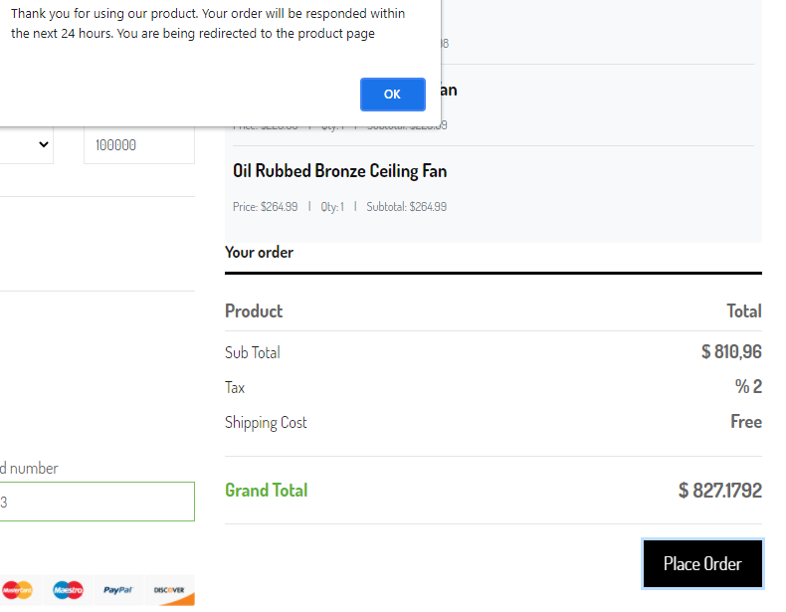

* **Feedback must be allowed to enter by the viewer(using Bootstrap, CSS & jQuery)**

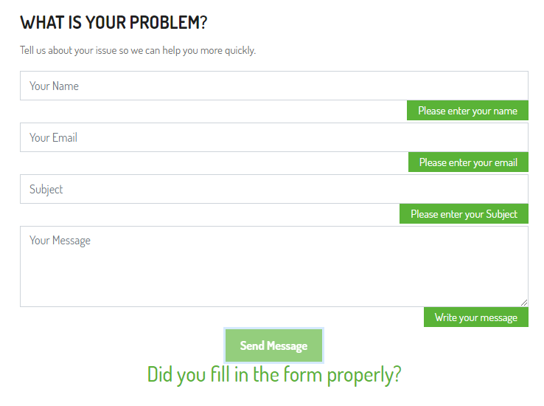

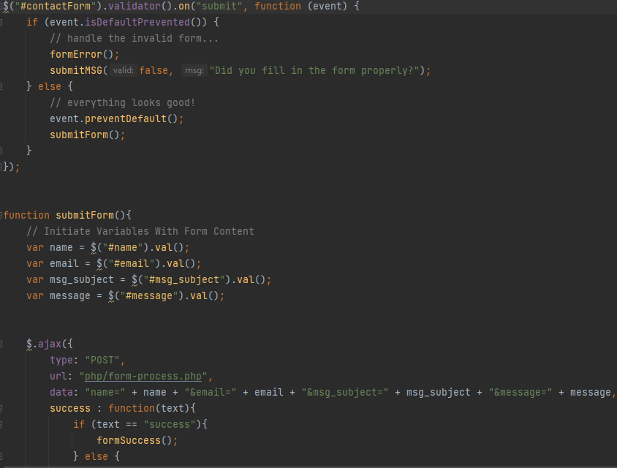

* Login & Register(using Boostrap & javascript)

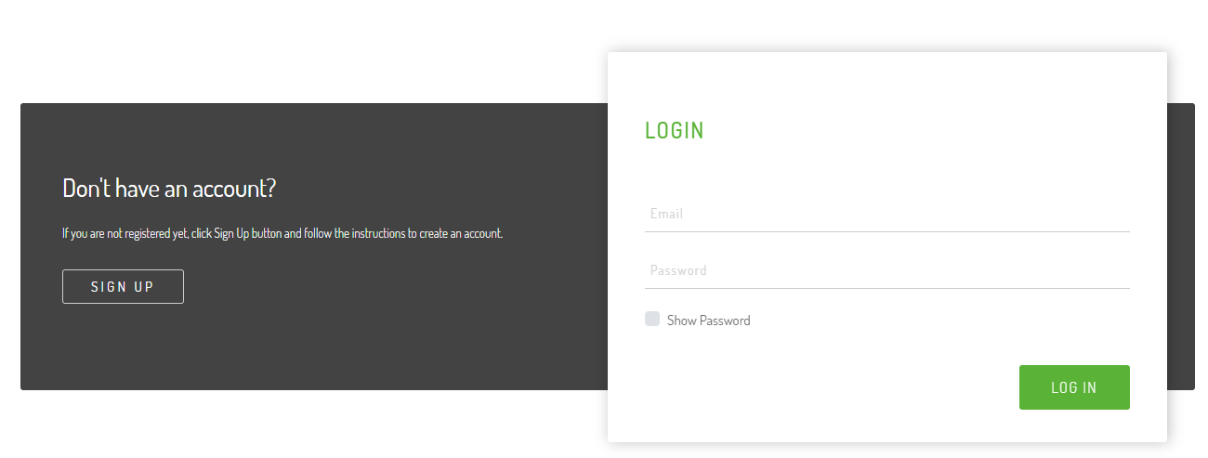

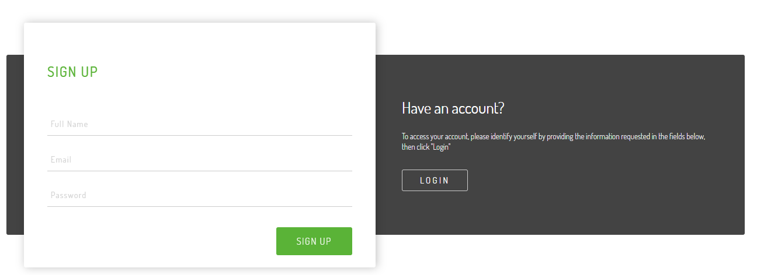

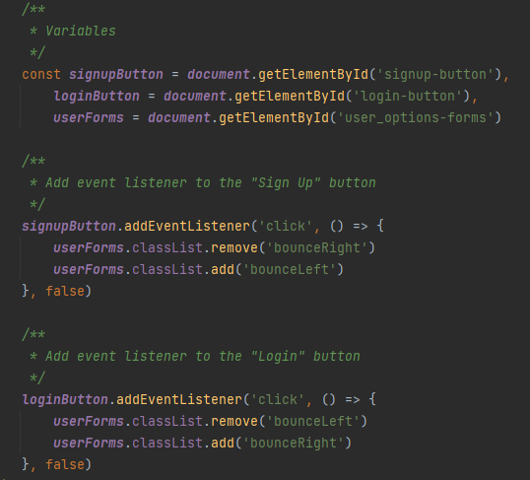

* Icon hover(using CSS)

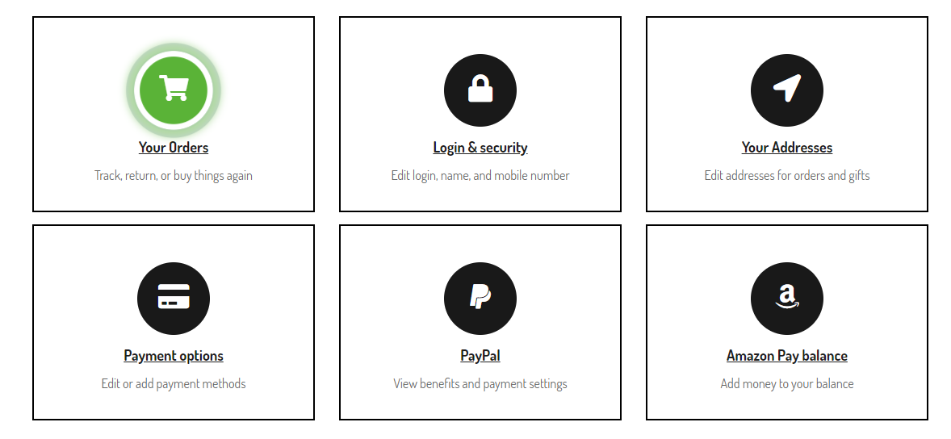

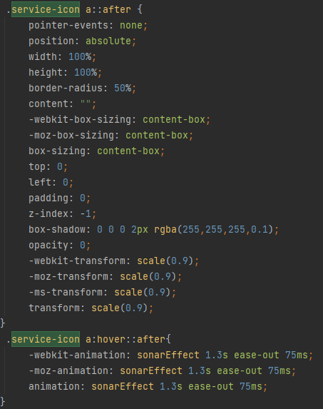

More details will be found in the files style.css(service-icon)

# Summary

* The (x) means that person took part in the individual work

|  |  |  |  |  |  |
| --- | --- | --- | --- | --- | --- |
| **STT** | **Page** | **Ta Hoang Ha** | **Nguyen Van Viet** | **Nguyen Ngoc Linh** | **Pham Van Nam** |
| 1. | Homepage | x |  |  |  |
| 2. | Header | x |  |  |  |
| 3. | Find resources: images and information of Fan |  | x |  |  |
|  | Logo design | x |  |  |  |
|  | Login & Register |  |  | x |  |
|  | Add to cart | x |  |  |  |
|  | Product | x |  |  |  |
|  | Product detail | x |  |  |  |
|  | Cart | x |  |  |  |
|  | Contact us |  | x |  |  |
|  | About us |  |  | x |  |
|  | Footer | x |  |  | x |
|  | Wishlist |  | x |  |  |
|  | Gallery |  |  |  | x |
|  | My Account |  | x |  |  |
|  | Merge Code | x |  |  |  |
|  | Write Report | x |  |  |  |
|  | SlideShow | x |  |  |  |
|  | Javascripts | x |  |  |  |